添加到Laser Cutting Practice - 0. Preparation - Turn on the laser下面

命名为：open windows and ventilate

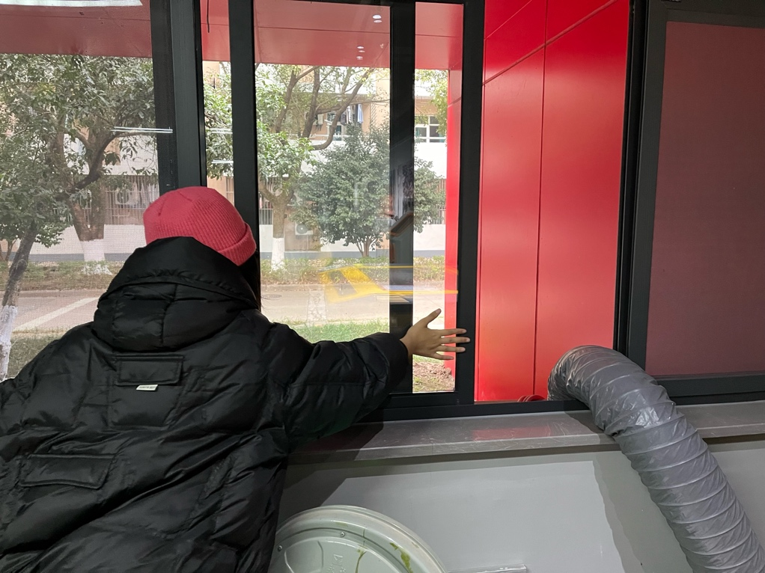

**新内容（图片注释见左下角）**

**Raspberry Pi meets laser cutting**

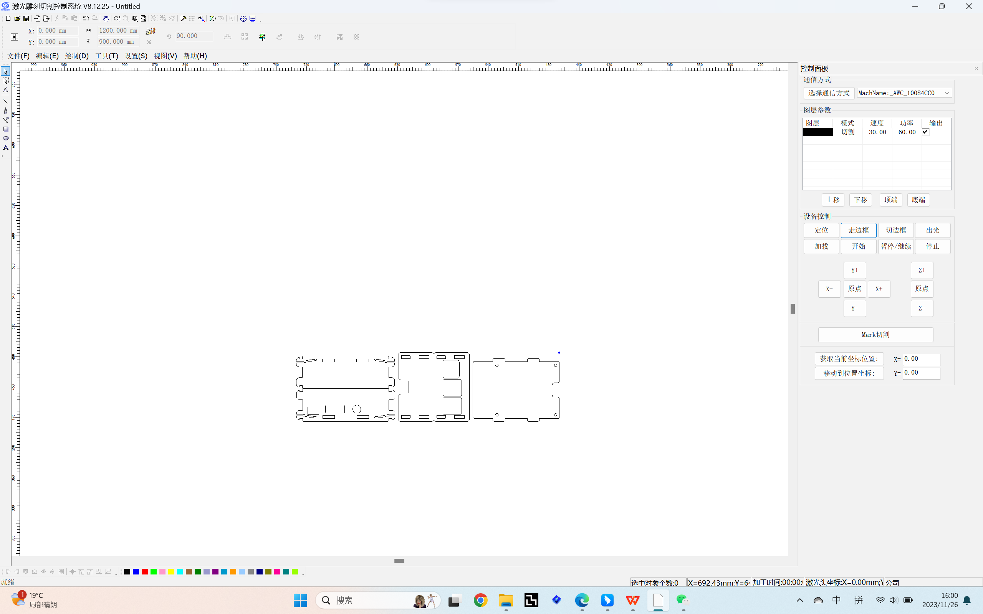

1 Design of parts drawings

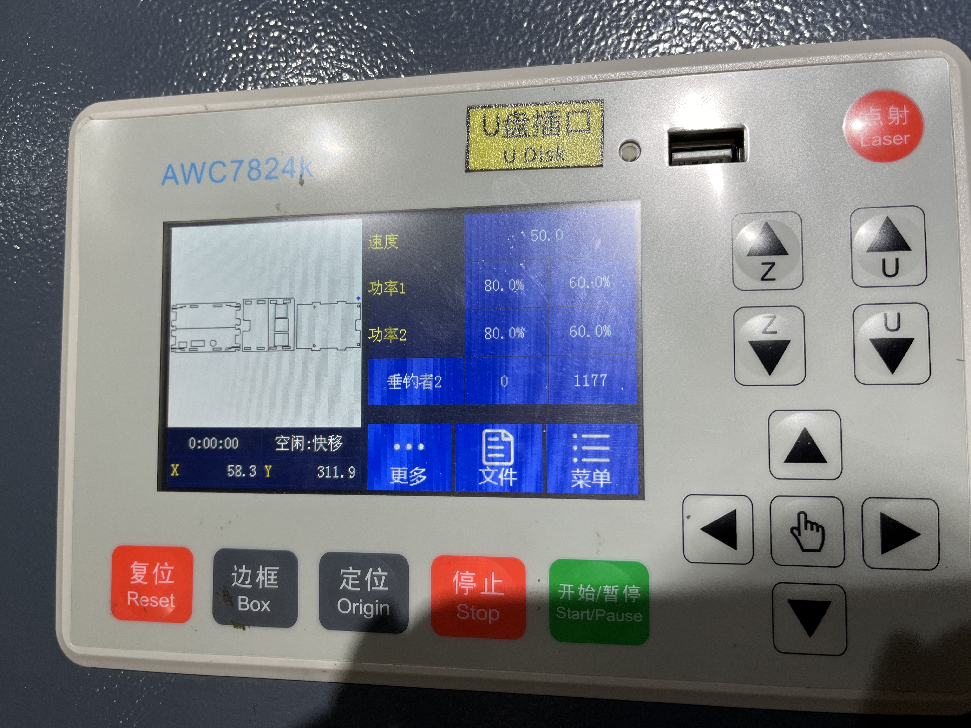

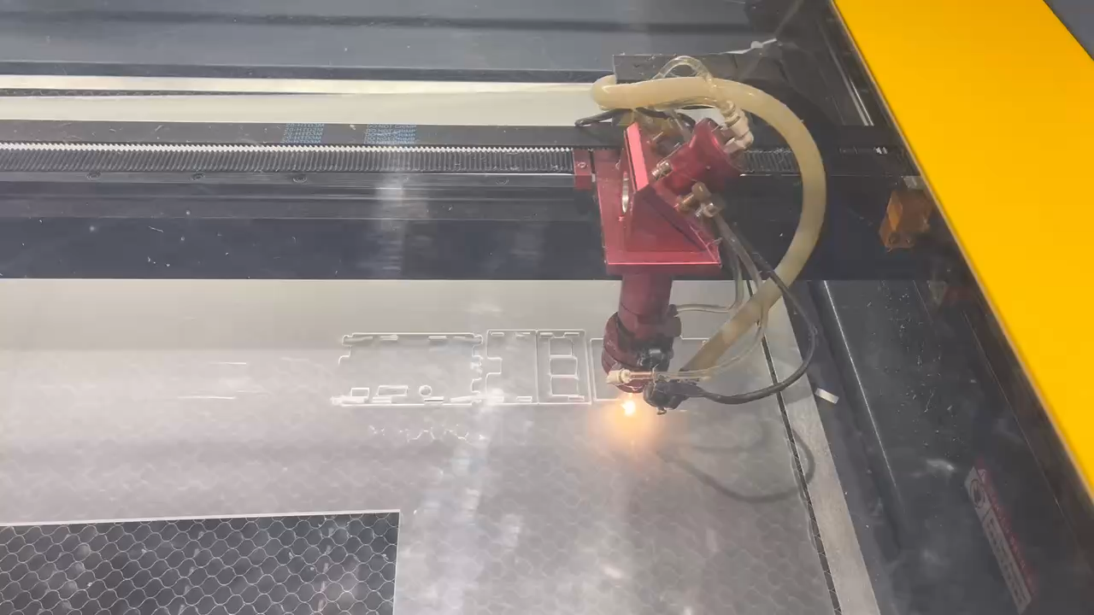2 Importing a design to start laser cutting

3 Laser cutting process

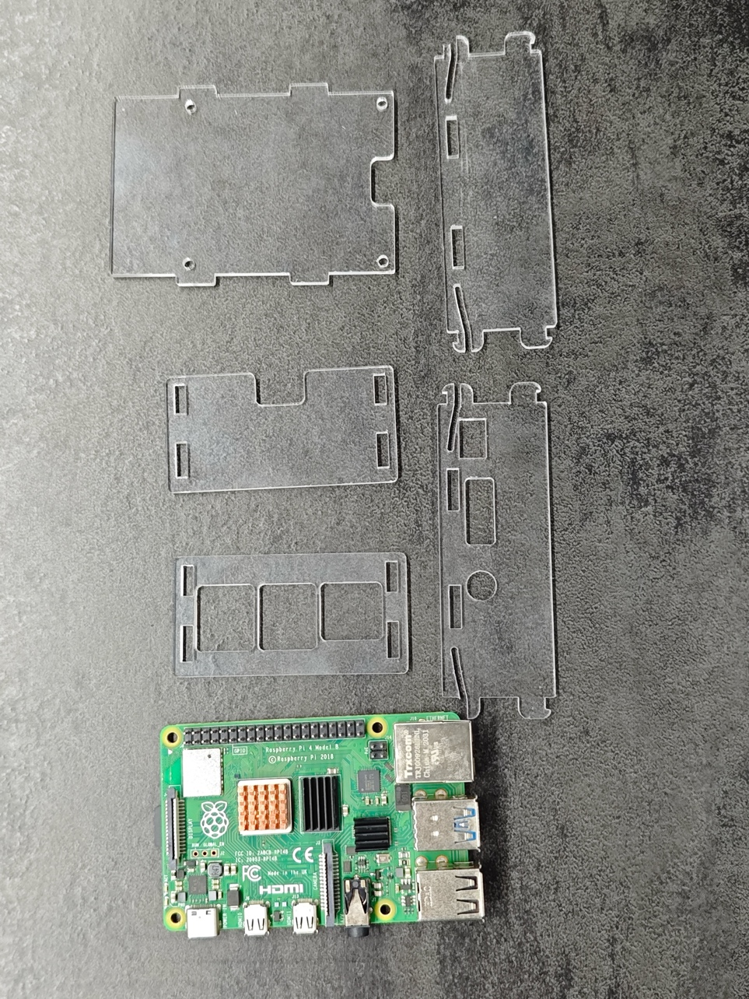

4 Laser cutting results

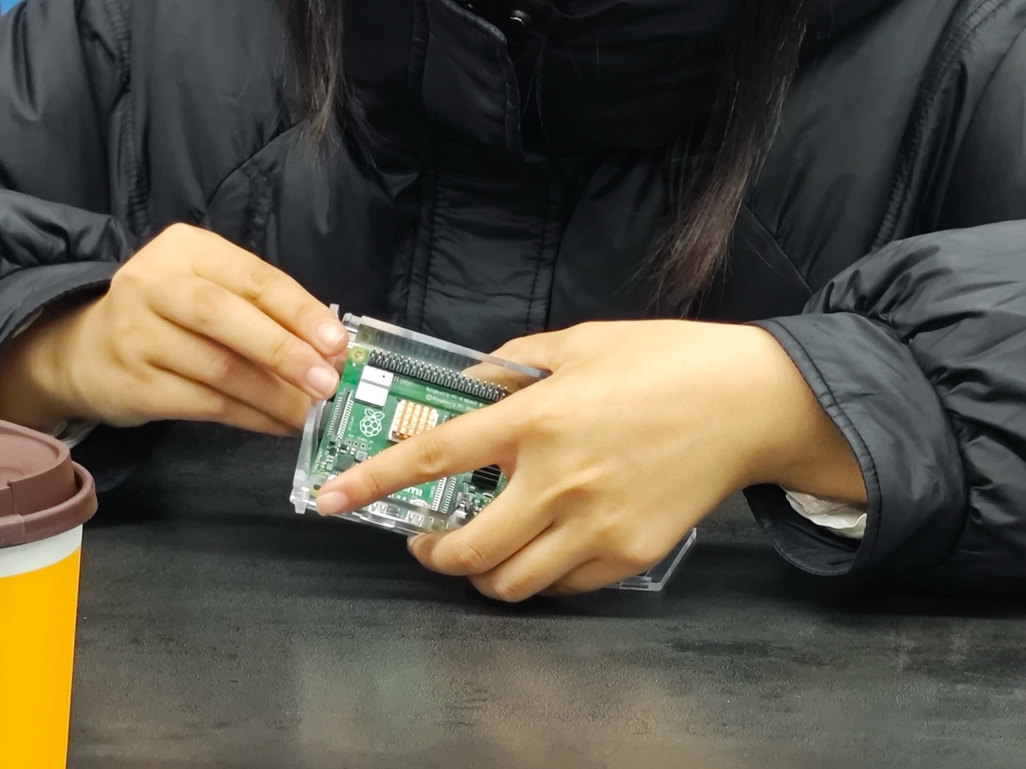

5 Assembly with Raspberry Pi

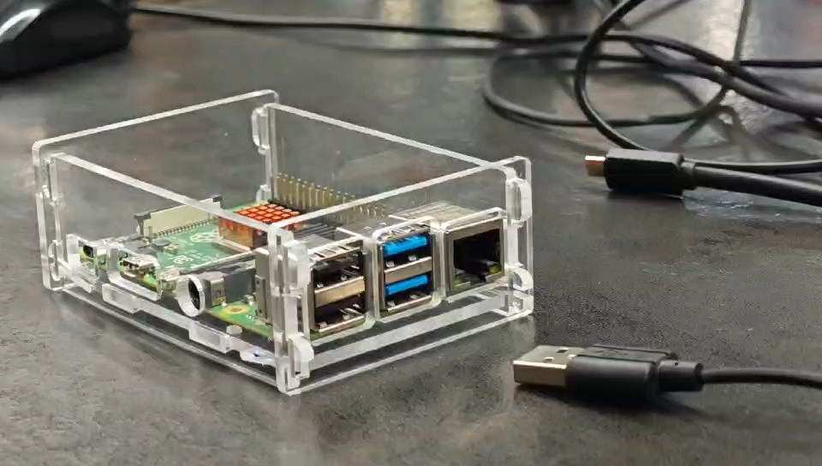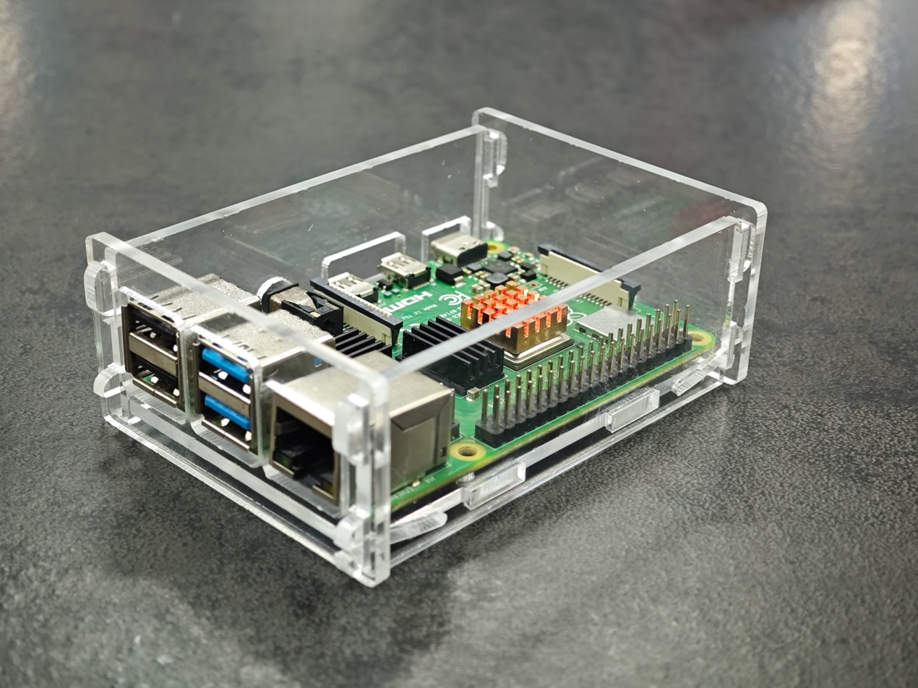

6 Assembly results

7 Details